**DAILY ONLINE ACTIVITIES SUMMARY**

|  |  |  |  |  |  |  |  |  |
| --- | --- | --- | --- | --- | --- | --- | --- | --- |
| **Date:** | **24-6-2020** | | | | | **Name:** | **Pavana P** | |
| **Sem & Sec** | **6A** | | | | | **USN:** | **4AL17CS057** | |
| **Online Test Summary** | | | | | | | | |
| **Subject** | |  | | | | | | |
| **Max. Marks** | |  | | **Score** | | |  | |
| **Certification Course Summary** | | | | | | | | |
| **Course** |  | | | | | | | |
| **Certificate Provider** | | |  | | **Duration** | | |  |
| **Coding Challenges** | | | | | | | | |
| **Problem Statement:**  1. Create a class named 'Shape' with a method to print "This is This is shape". Then create two other classes named 'Rectangle', 'Circle' inheriting the Shape class, both having a method to print "This is rectangular shape" and "This is circular shape" respectively. Create a subclass 'Square' of 'Rectangle' having a method to print "Square is a rectangle". Now call the method of 'Shape' and 'Rectangle' class by the object of 'Square' class. | | | | | | | | |
| **Status: Completed** | | | | | | | | |
| **Uploaded the report in Github** | | | | | **YES** | | | |
| **If yes Repository name** | | | | | **DAILY STATUS** | | | |
| **Uploaded the report in slack** | | | | | **YES** | | | |

.

**Workshop and Quiz**

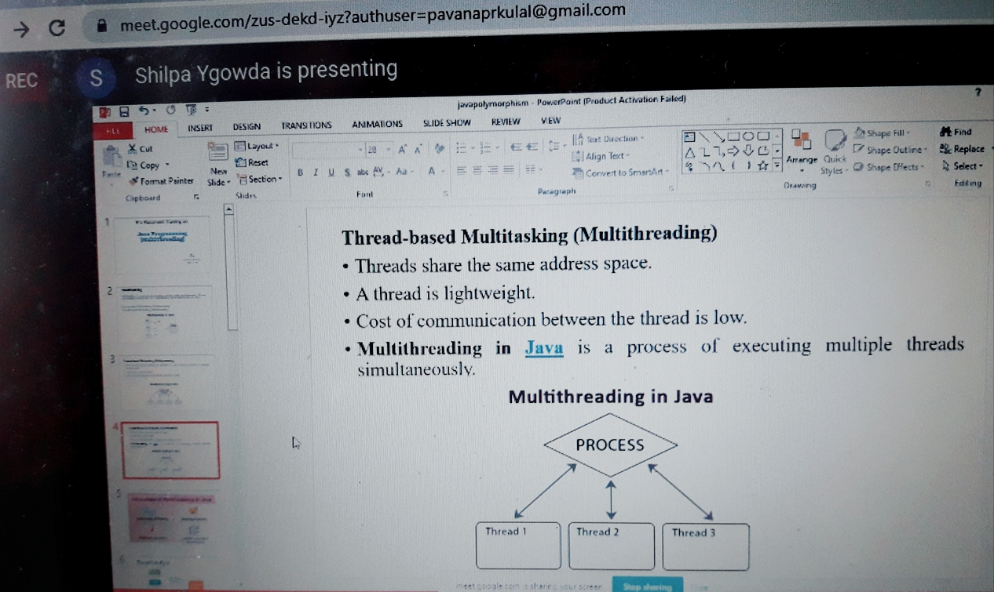

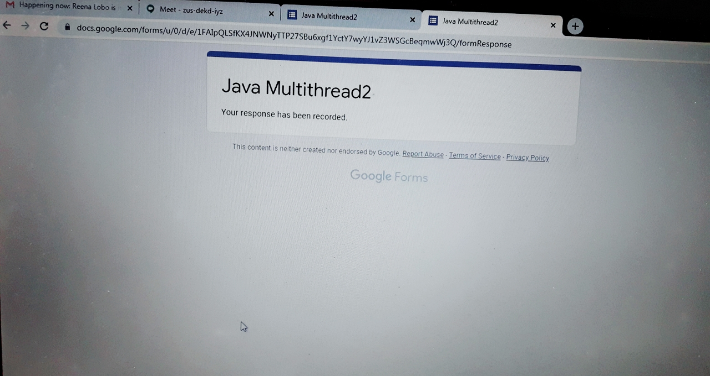

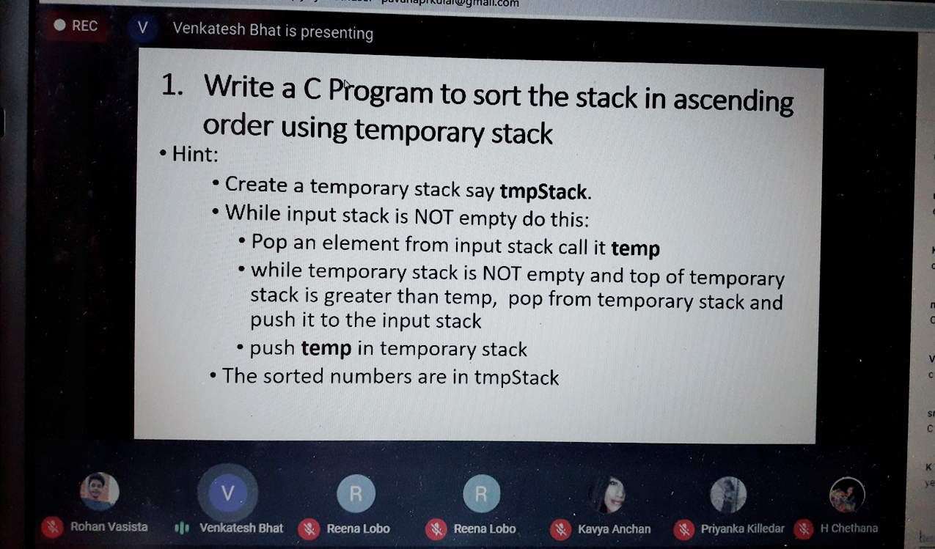

.**Coding Challenges Details:**

**https://github.com/pavana-p-kulal/DAILY-STATUS/tree/master/24-6-20/Online%20Coding**